**WEEK-6**

**REACT**

**4.ReactJS-HOL**

**Create a new react application using *create-react-app* tool with the name as “blogapp”**

**CODE:**

**Step 1: Create React Application , Open terminal or command prompt and run:**

**npx create-react-app blogapp**

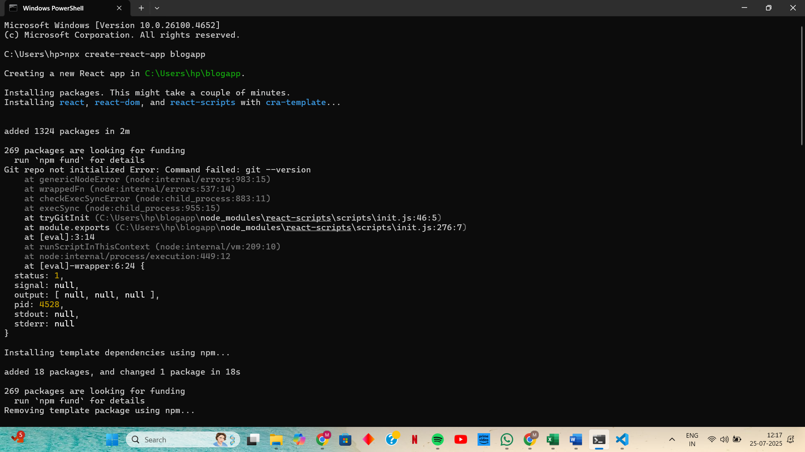

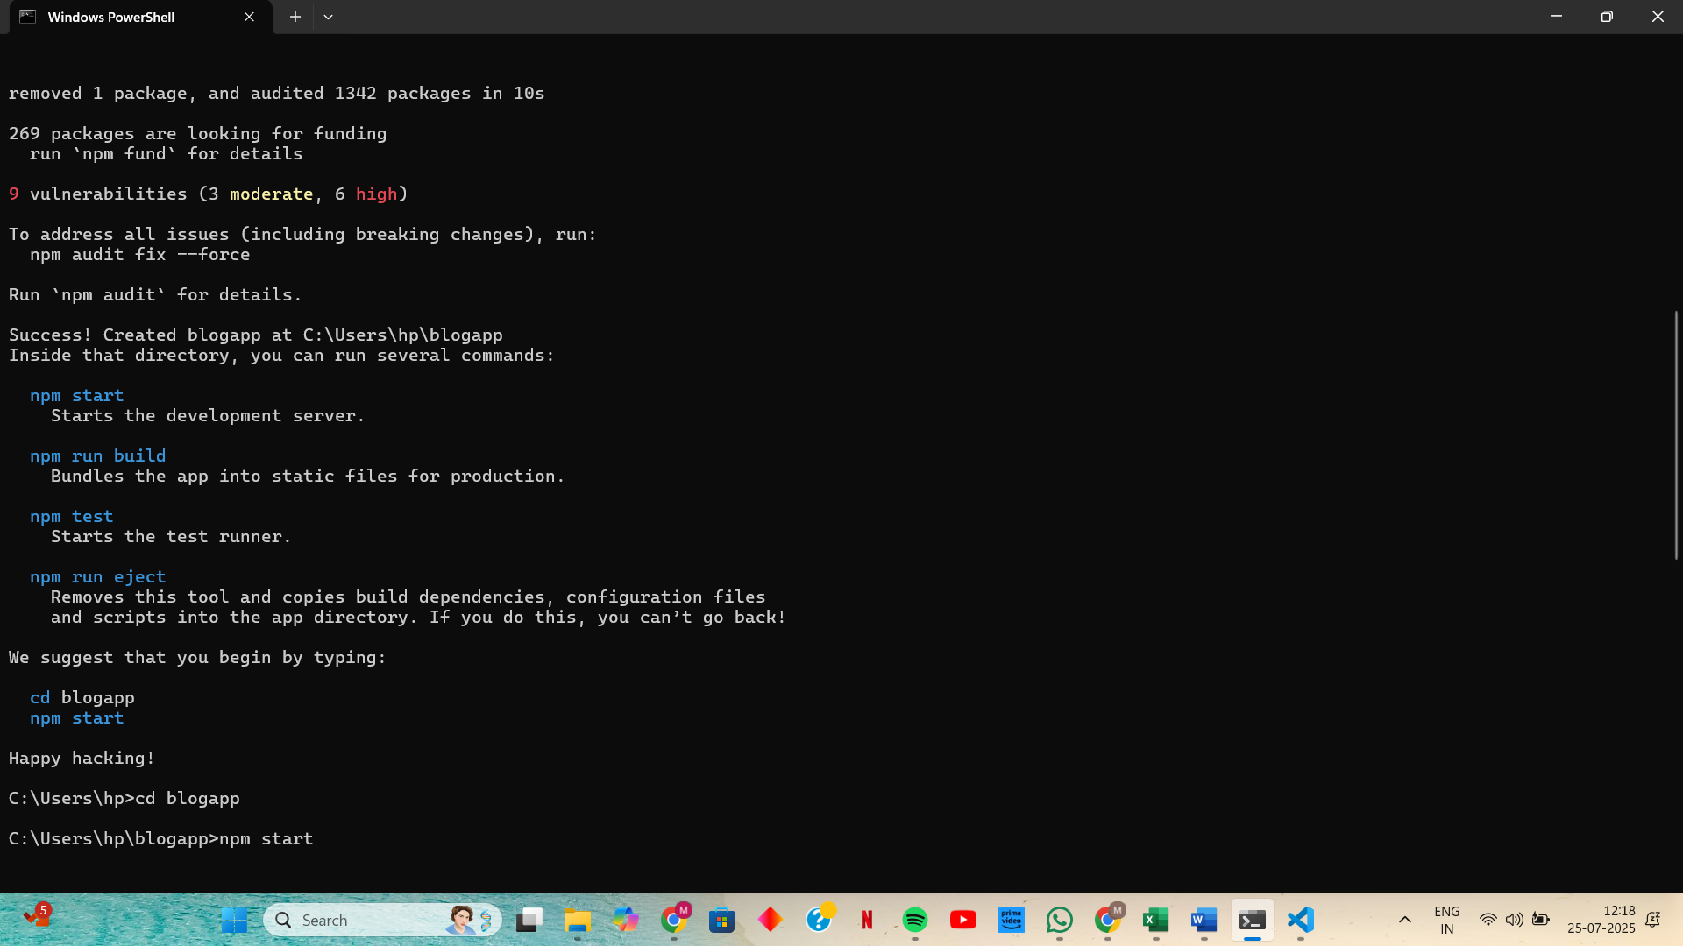

**Step 2: Create Post.js inside src**

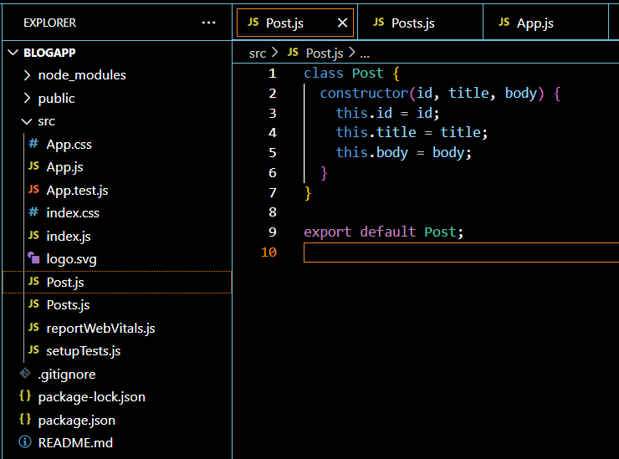

**Step 3: Create Posts.js inside src**

**Step 4: Add loadPosts() method in Posts.js**

**Step 5: Implement componentDidMount() hook**

**Step 6: Implement render() method**

**Step 7: Implement componentDidCatch() for error handling**

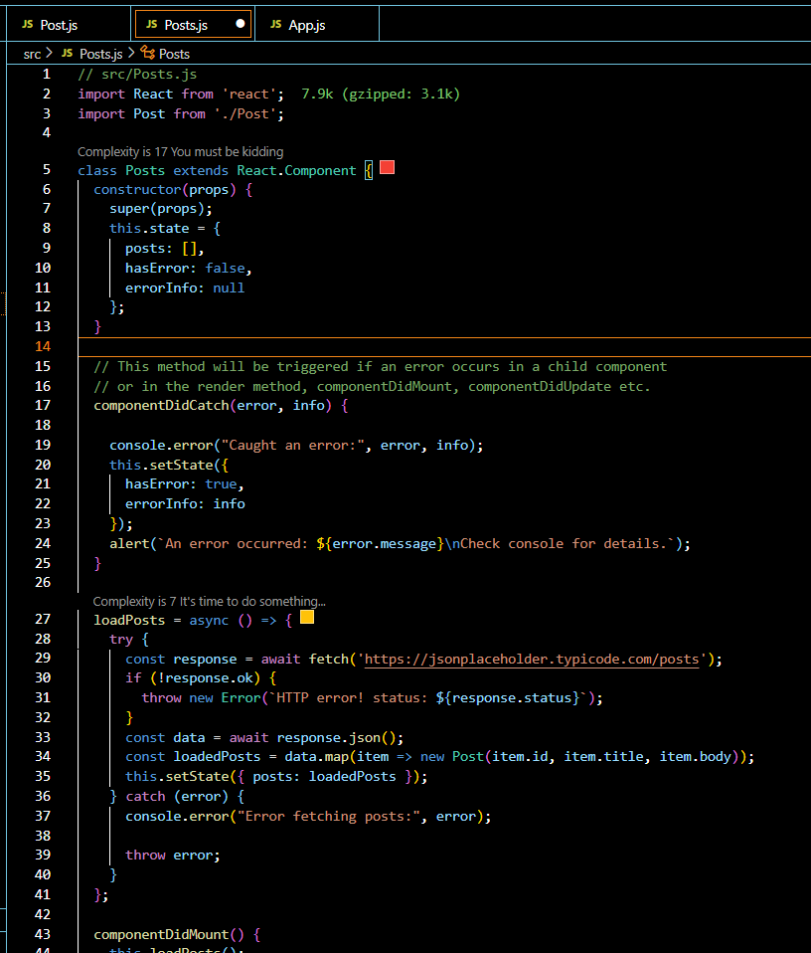

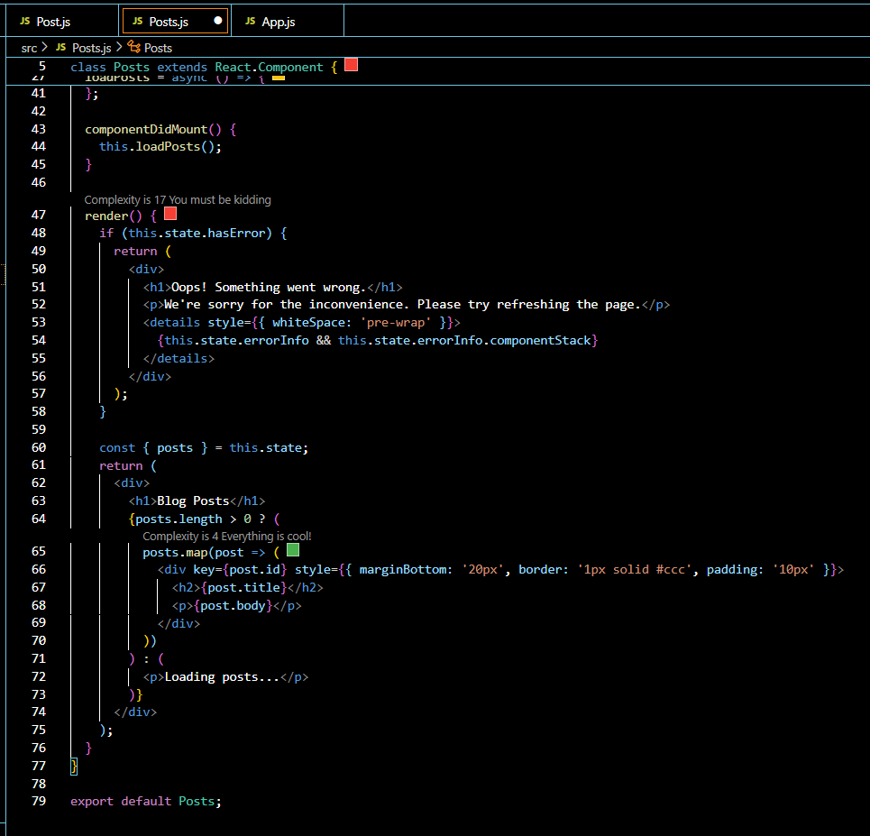

**Step 8: Add Posts component in App.js**

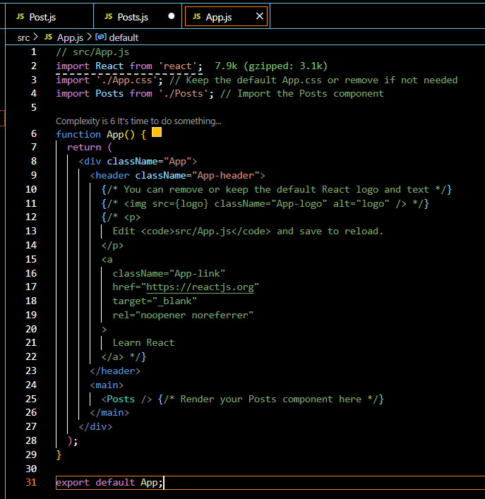

**Step 9: Run application in cmd : npm start**

**OUTPUT:**

